LAB 3: Dynamic Systems Modeling in Simscape

Course Number | MENG 3020
Course Title | System Modeling & Simulation
Semester/Year | Fall 2025

Lab/Tutorial Report No. | Lab 3
Report Title | Dynamic Systems Modeling in Simscape
Section No. | ONA
Group No. | N/A
Submission Date | October 19th, 2025
Due Date | October 19th, 2025

Student Name | Signature* | Total Mark
Michael McCorkell |  | / 50

* By signing above, you attest that you have contributed to this submission and confirm that all work you have contributed to this submission is your work. Any suspicion of copying or plagiarism in this work will result in an investigation of Academic Misconduct and may result in a ZERO on the work or possibly more severe penalties.
https://academic-regulations.humber.ca/2021-2022/17.0-ACADEMIC-MISCONDUCT

LAB 3 Grading Sheet

Student First Name:  Michael | Student Last Name:  McCorkell
Part A.1: Build the Model, Set the Component Parameters & Run the Simulation |  | /5
Part A.2: Current Circulation in the Active Phase & Freewheel Phase |  | /10
Part A.3: Effect of the Duty-Cycle on the Motor Voltage & Motor Speed |  | /10
Part A.4: Effect of the Rotor Inertia and Armature Inductance on the Motor Speed |  | /10
Post Lab Assignment |  | /10
General Formatting: Clarity, Writing style, Grammar, Spelling, Layout of the report |  | /5
Total Mark |  | /50

LAB 3: Dynamic Systems Modeling in Simscape

OBJECTIVES
- To model and simulate a buck converter system in Simscape to speed control of a DC motor.
- To understand the circulation of the current in the circuit in active phase and in freewheel phase.
- To visualize and evaluate the effect of the duty cycle, switching frequency and the inductance value on the current, voltage and speed of DC motor.

Simpscape Model of DC Motor Control by Buck Converter
Introduction
A Buck Converter is a DC-to-DC power converter, which steps down voltage from its input (source) to output (load). It typically contains two semiconductor switches, a diode, and a transistor, to control the direction of the current in the circuit. Buck converters enable us to obtain an adjustable DC voltage from a fixed DC voltage, which is particularly used to speed control of DC motors. Figure 1 shows a typical configuration of a simple buck converter.
PWM Control
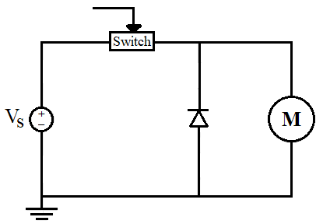
K₁
K₂
Figure 1: Typical Buck Converter

V_{s} is a fixed DC voltage source. M is a brushed DC motor. Switch K₁ is a power transistor which can be turned ON and OFF by a PWM control signal. Switch K₂ is a diode, which is called flyback or freewheeling diode.
A PWM controlled buck converter has two phases of operation: Active phase and Freewheel phase.
In the active phase, switch K₁ is ON, and K₂ is OFF.
- The current that passes through the motor is identical to that passes through the supply.
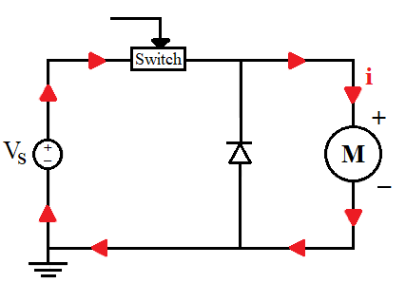
- The current in the diode branch is zero.
K₁
K₂
PWM Control
- The high frequency PWM signal turns ON and OFF the K₁ switch at a fast rate, which allows us to adjust the average or effective value of the applied voltage to the DC motor.
- The average voltage depends on the duty cycle of the PWM signal.
- Duty cycle is the amount of time the PWM signal is ON versus the amount of time the signal is OFF in a single period.
$$Duty\text{-}cycle\text{=} \frac{τ_{o}}{τ_{c}}$$
- The effective applied voltage $V_{e}$ is determined as:
$$V_{e}\text{=}V_{s} \frac{τ_{o}}{τ_{c}}$$
which increases by increasing the duty-cycle of the PWM signal.
In the freewheel phase, switch K₁ is OFF, and K₂ is ON.
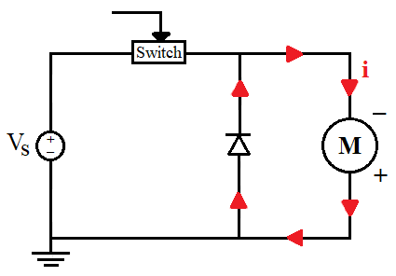
- The current that passes through the motor is identical to that passes through the diode branch.
K₁
K₂
PWM Control
- The current in the supply is zero.
- Turning OFF the switch K₁ does not immediately stop current in the motor windings.
- The inductive behavior of the DC motor causes current to continue to flow when the switch K₁ is opened suddenly.
- Adding a flyback diode in parallel with the motor provides a path for dissipation of stored energy when the switch K₁ is OFF.

A.1. Build the Model, Set the Component Parameters & Run the Simulation
- Open a new Simulink model page. Find and place the following elements and components from the Simulink Library Browser.
  - Simscape > Foundation Library > Electrical > Electrical Elements > Diode
  - Simscape > Foundation Library > Electrical > Electrical Elements > Electrical Reference
  - Simscape > Foundation Library > Electrical > Electrical Sources > DC Voltage Source
- Simscape > Foundation Library > Mechanical > Rotational Elements > Mechanical Rotational Reference
- Simscape > Foundation Library > Mechanical > Mechanical Sensors > Ideal Rotational Motion Sensor
  - Simscape > Electrical > Semiconductors & Converters > MOSFET (Ideal Switching)
  - Simscape > Electrical > Electromechanical > Brushed Motors > DC Motor
- Simscape > Electrical > Specialized Power Systems > Sensors and Measurements > Mean
  - Simscape > Utilities > PS-Simulink Converter
- Simscape > Utilities > Simulink-PS Converter
  - Simscape > Utilities > Solver Configuration
  - Simulink > Sinks > Scope
  - Simulink > Sinks > Display
  - Simulink > Sources > Pulse Generator
- Arrange and connect the blocks as shown below. The model involves the electrical field and the mechanical rotational field:
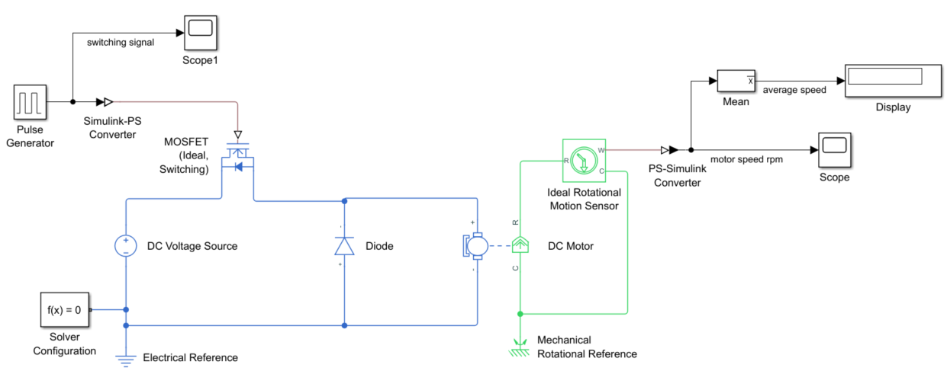

- Provide your final Simscape model diagram below:

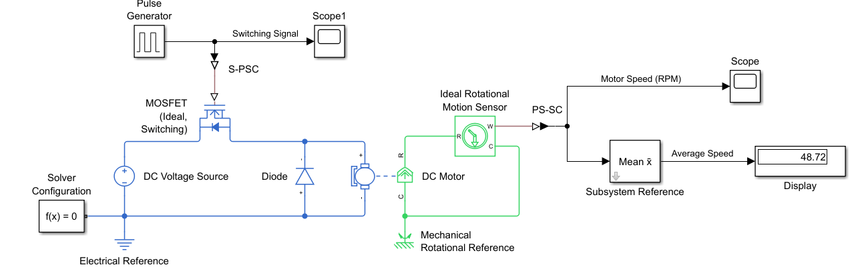

- Open the Block Parameters by double-clicking on the appropriate block. Enter the following values for each component:
- Pulse Generator:
Amplitude = 1, Period = 0.001 sec, Pulse Width = 50 percent, Phase delay = 0 second
- DC Voltage Source:
Constant Voltage = 24 V
- MOSFET (Ideal Switch):
Drain-source on resistance = 0.01 Ohm, Off-state conductance = 1e-6 1/Ohm, Threshold voltage = 0.5 V
- Diode:
Forward voltage = 0.1 V, On resistance = 0.1 Ohm, Off conductance = 1e-8 1/Ohm
- DC Motor:
Armature resistance = 20 Ohm, Armature inductance = 100 mH, Back-emf constant = 9e-4 V/rpm
Rotor inertia = 0.5 g.cm², Rotor damping = 0.001 Nm/(rad/s), Initial rotor speed = 0 rpm
- Mean:
Fundamental frequency = 1000 Hz
- Motion Sensor:
Deselect the Position and Acceleration outputs.
- PS-Simulink Converter:
Set the Output signal unit to rpm.
- Click on the Model Settings icon in the MODELING tab to open the Configuration Parameters window. Click on the Solver drop down menu and select the ode23t solver. Then click OK.
- Save the model file as Lab3_PartA.slx. Set the simulation Stop Time to 0.05sec and Run the simulation. Open the Scope blocks. You will see the switching signal with the frequency of 1kHz and the rotational speed of the DC motor in rpm. Provide the graphs below:

Switching PWM Signal DC Motor Speed (rpm)

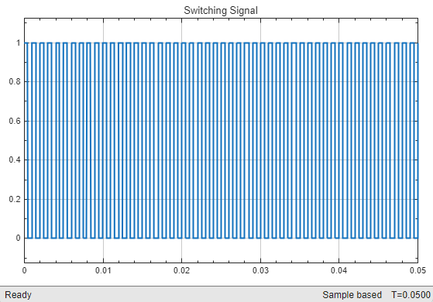

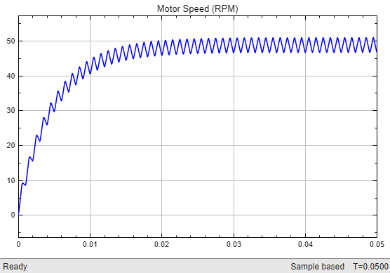

- Since the PWM switching frequency is very fast and the load inertia is very low, the commutation frequency causes ripple in the motor speed. What is the average final speed of the motor?
48.72 RPM

A.2. Current Circulation in the Active Phase & Freewheel Phase
To view the current circulation in the buck converter, we will modify the Simscape model by adding the current sensors in each of the circuit branches.
- Select and place the following blocks from the library and modify the circuit diagram as shown below:
- Simscape > Foundation Library > Electrical > Electrical Sensors > Current Sensor
  - Simscape > Utilities > PS-Simulink Converter
  - Simulink > Sinks > Scope
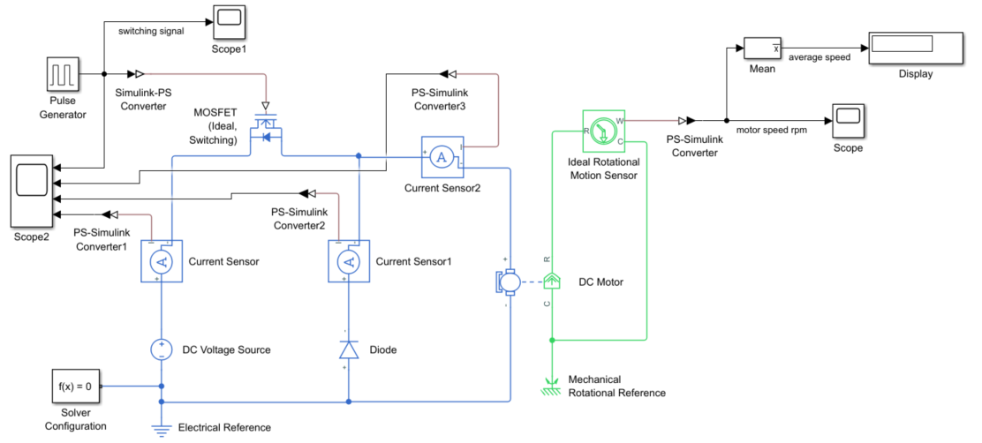

- Provide your Simscape model diagram below:
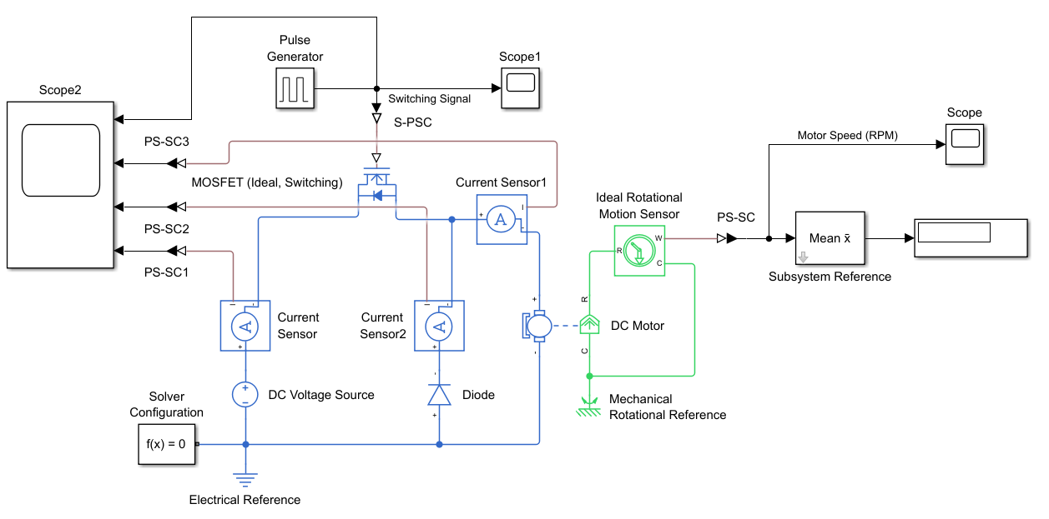

- To better understanding the current flow, we set the frequency of the switching signal in Pulse Generator to 10Hz.
- Adjust the Fundamental frequency in Mean block to 10Hz to match with the switching frequency.
- Set the simulation Stop Time to 0.1 sec and Run the simulation.
- Open the Scope block to view the currents waveform of each branch in the circuit.
- Provide the currents waveform graph below. Identify the active phase and freewheel phase on the graph.
Currents Waveform
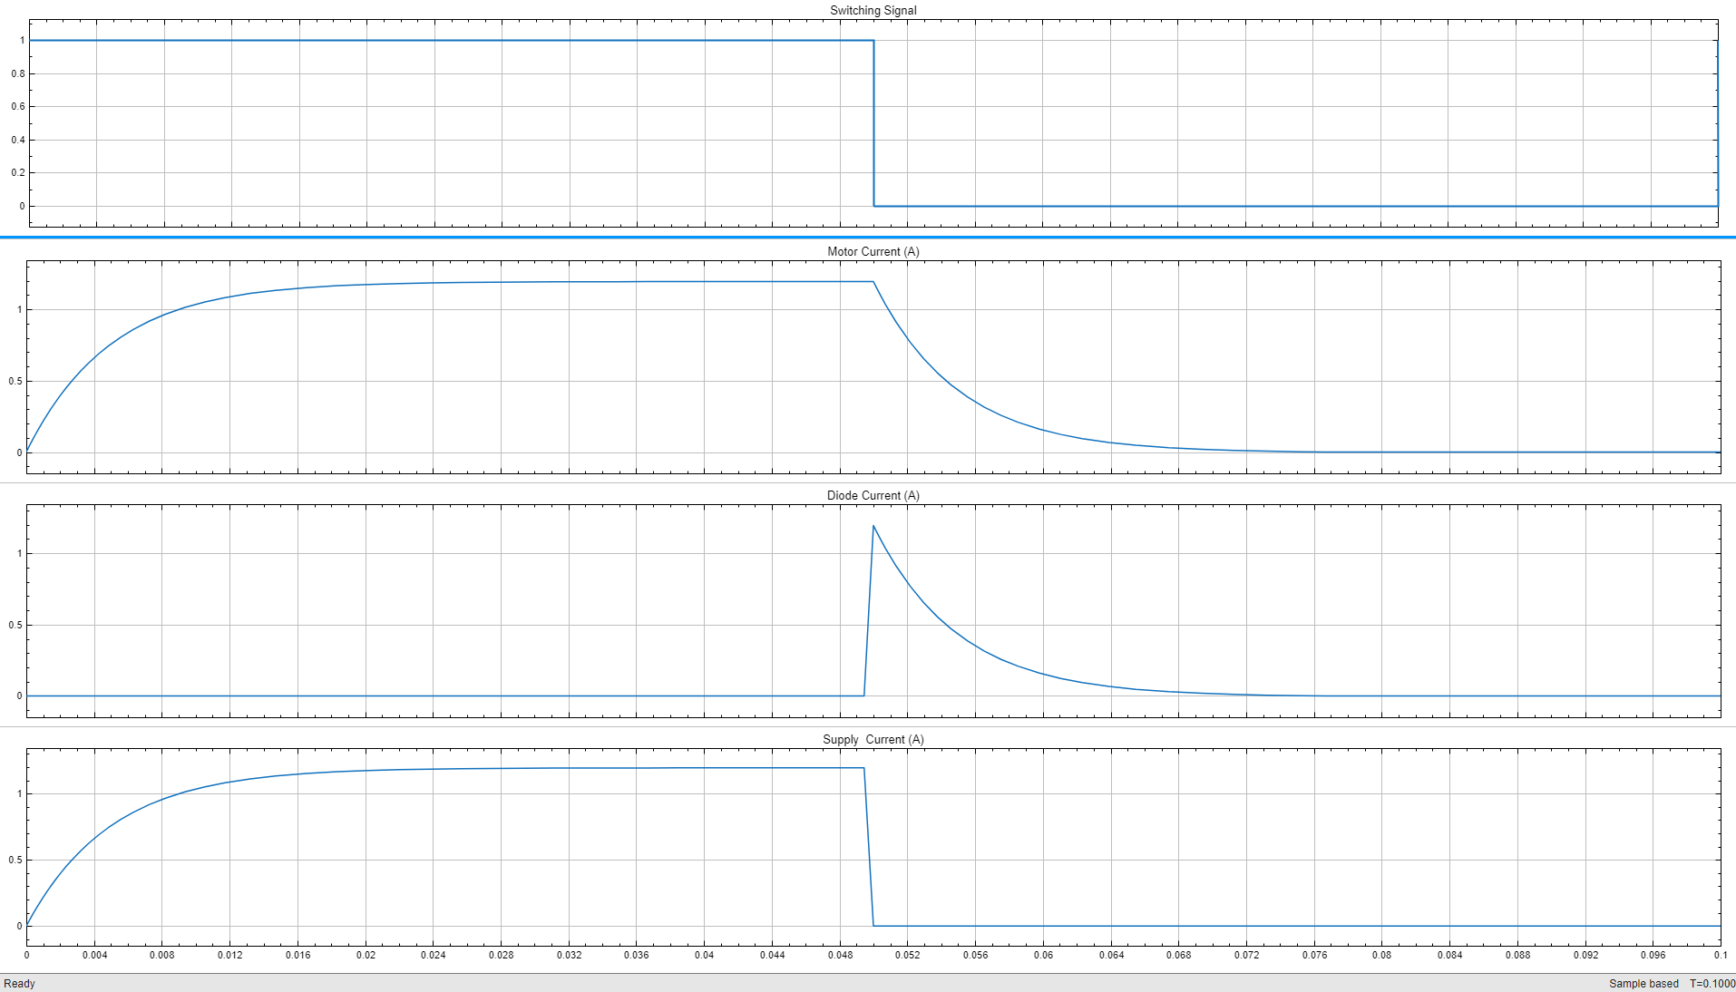

- Briefly describe the current waveforms and the motor speed in the active phase and the freewheel phase.
In the active phase, both motor speed and current increase until they reach their maximum. During the freewheeling phase, the diode provides a path for the motor current, allowing it to gradually decay rather than stopping abruptly, so the motor continues to coast while the current waveform slowly decreases.



K₁
K₂
PWM Control
K₁
K₂
PWM Control

Active Phase Freewheel Phase

- To check the effect of the switching frequency on the current waveforms, set the switching frequency to the given values in Table 1. Observe the current waveforms and collect the average motor speed data. Make sure to change the Fundamental frequency of the Mean block based on the assigned switching frequency.
Table 1
Switching Frequency | 10 Hz | 20 Hz | 40 Hz | 80 Hz | 200 Hz | 500 Hz
Average Speed (rpm) | 48.91 | 48.79 | 48.76 | 48.74 | 48.73 | 48.72

- Briefly describe the effect of increasing the switching frequency on the current ripples and the motor speed.
Increasing the switching frequency slightly reduces the current ripples in the motor, as the voltage is applied in shorter, more frequent pulses, allowing the motor’s inductance to smooth the current more effectively. However, the average motor speed shows only a minimal decrease with higher switching frequencies, as seen in the table, indicating that the primary effect of increasing frequency is improved current stability rather than significant changes in speed.

A.3. Effect of the Duty-Cycle on the Motor Voltage & Motor Speed
In this step the goal is to observe the variation of the average applied voltage and speed of the DC motor by changing the duty-cycle of the PWM signal.
- Modify the Simscape model from previous part by adding the following components as shown below:
- Simscape > Foundation Library > Electrical > Electrical Sensors > Voltage Sensor
- Simscape > Electrical > Specialized Power Systems > Sensors and Measurements > Mean
- Simscape > Utilities > PS-Simulink Converter
- Simulink > Sinks > Scope
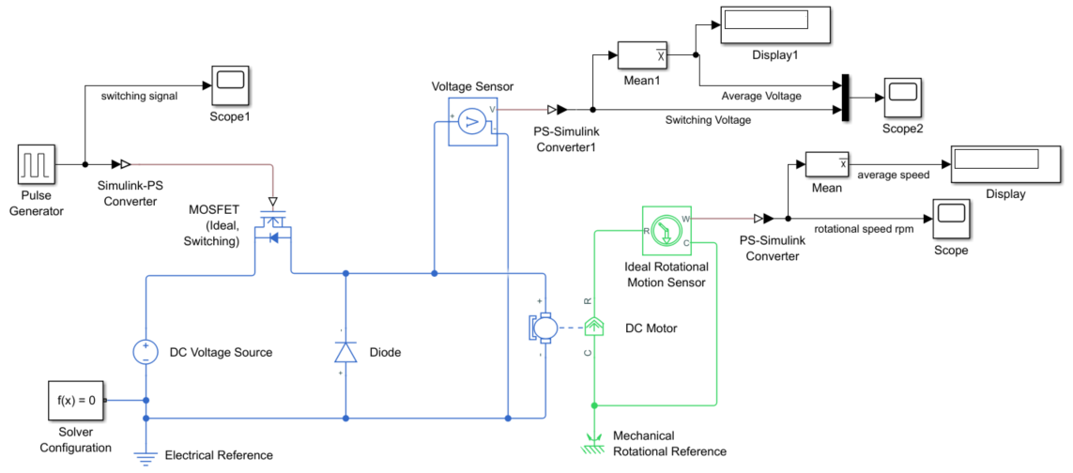
- Set back the Pulse Generator parameters to the give original values.
Amplitude = 1, Period = 0.001 sec, Pulse Width = 50 percent, Phase delay = 0 second
- Set the Fundamental frequency of the Mean blocks to 1000 Hz.
- Provide your Simscape model diagram below:
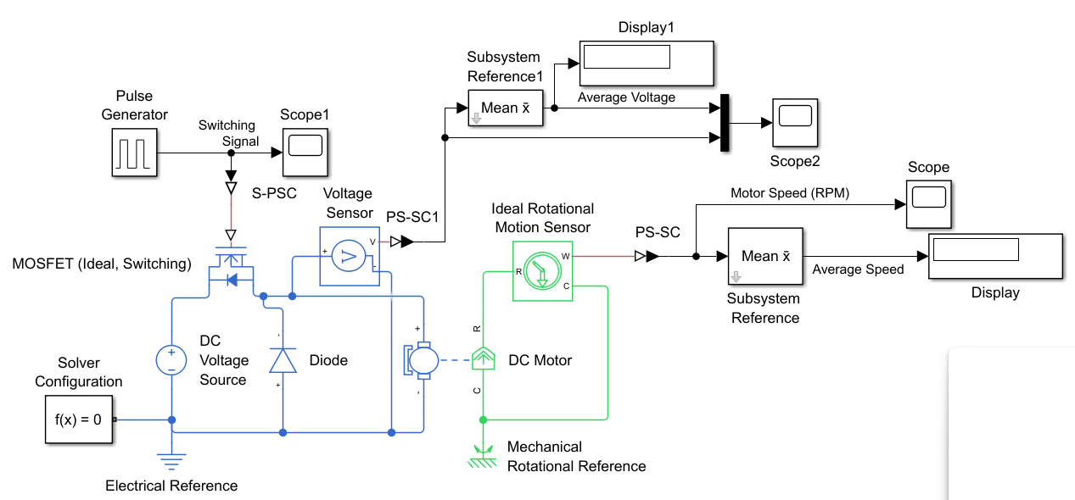

- Change the duty-cycle of the PWM switching signal in the Pulse Generator block for each of the given values in Table 2. Run the simulation for 0.05sec in each case. Provide the required graphs, calculations, and data from the simulation and complete Table 2.
Table 2
Duty-Cycle | 10% | 30% | 50% | 70% | 90% | 99%
Average Speed (rpm) | 9.401 RPM | 29.04 RPM | 48.72 RPM | 68.43 RPM | 88.18 RPM | 97.08 RPM
Average Voltage (V) | 2.3 V | 7.104 V | 11.92 V | 16.74 V | 21.57 V | 23.75 V
Provide required samples of simulation graphs below:
Applied Voltage (V) (Duty-cycle = 30%) DC Motor Speed (rpm) (Duty-cycle = 30%)

Applied Voltage (V) (Duty-cycle = 90%) DC Motor Speed (rpm) (Duty-cycle = 90%)

- Briefly describe the effect of increasing the duty-cycle on the ripples, the average motor speed, and the average voltage applied to the motor.
As the duty cycle of a PWM signal increases, the average voltage applied to the motor rises, causing the motor to spin faster and increasing its average speed. At the same time, the ripples in voltage and speed are reduced, resulting in smoother and more stable operation. In this way, a higher duty cycle not only boosts the motor’s performance but also improves its consistency.

A.4. Effect of the Rotor Inertia and Armature Inductance on the Motor Speed

In this part, the goal is to observe the effect of the rotor inertia and the armature inductance on the average motor speed and the ripple.
- Set back the Pulse Generator parameters to the original values.
Amplitude = 1, Period = 0.001 sec, Pulse Width = 50 percent, Phase delay = 0 second
- Double-click on the DC Motor block and change the Rotor inertia first to 10 g.cm² and then to 0.001 g.cm²
- Run the simulation for 0.05sec and open the Scope block and check the motor speed for each case. Provide the speed graphs and the average final speed below.

DC Motor Speed (Rotor Inertia = 10 g.cm²) DC Motor Speed (Rotor Inertia = 0.001 g.cm²)
48.72

48072

Average Final Speed (rpm): Average Final Speed (rpm):

- Explain the effect of variation of rotor inertia on the ripple, time constant and the average speed of the motor.
When the rotor inertia was adjusted to 10, the ripples decreased, but the time constant and average speed stayed unchanged. Conversely, reducing the rotor inertia to 0.001 caused an increase in ripples, while the time constant and average speed remained unaffected.

- Set back the Rotor inertia to the original value of 0.5 g.cm².
- Double-click on the DC Motor block and change the Armature inductance first to 1 H and then to 10 mH.
- Run the simulation and open the Scope block and check the motor speed for each case. Provide the speed graphs below.
NOTE: For L_{a} = 1H set the simulation time to 0.5 sec and for L_{a} = 10mH set the simulation time to 0.02 sec to capture the full speed response graph.

DC Motor Speed (L_{a} = 1 H) DC Motor Speed (L_{a} = 10 mH)
48.72

48.73

Average Final Speed (rpm): Average Final Speed (rpm):

- Explain the effect of changing the Armature inductance on the ripple, time constant and the average speed of the motor.
Setting the armature inductance to 1 H considerably eliminates ripples, decreases the time constant, and keeps the average speed virtually constant. When the inductance is increased to 10 mH, the ripples rise significantly, the time constant accelerates, but the average speed remains essentially constant.

Post Lab Assignment
- Build the Simscape physical diagram for the following electric circuit.
$$R_{1}\text{=}0.2 Ω, R_{2}\text{=}1 Ω, C\text{=}0.01 F, L\text{=}0.1 H$$
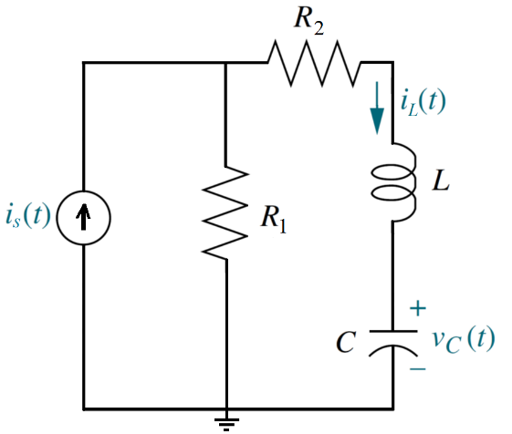
- Provide your Simscape model diagram.
- Select an appropriate simulation time and plot the voltage across the capacitor $v_{c}(t)$ and current through the inductor $i_{L}(t)$ if the input signal is $i_{s}\left(t\right)\text{=}0.5 A$ and all initial conditions are $v_{c}\left(0\right)\text{=}0$ and $i_{L}\left(0\right)\text{=}0$. Provide the graphs.
- What is the final voltage of the capacitor? What is the final current of the inductor?
- Set the initial conditions to $v_{c}\left(0\right)\text{=}2 V$ and $i_{L}\left(0\right)\text{=}0.5 A$. Plot the voltage $v_{c}(t)$ and current $i_{L}(t)$ graphs. Provide the graphs?
- What is the final voltage of the capacitor? What is the final current of the inductor?

Post Lab)
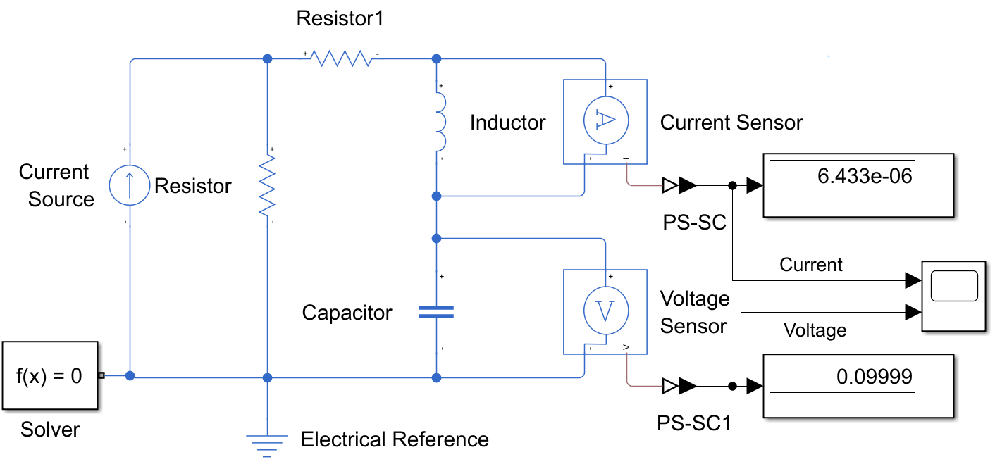
a)

b) The final Stop time is 2 sec

C)
Final Value
Induction (L): 0 A
Capacitor (C): 0.1 V

D)

E)
Final Value
Induction (A): -0.5001 A
Capacitor (V): 0.1001 V

